IJEEERD
© PRJ PUBLICATION
International Journal of Mechanical Engineering Research and Development (IJMERD)

ISSN Print: 2248-9347
ISSN Online: 2248-9355

Volume 6 Issue 1, January-April (2017), pp 01-07
Copywright@PRJ:www.prjpublication.com/ijeeerd.asp

EXPERIMENTAL INVESTIGATION ON THE ALUMINIUM METAL MATRIX COMPOSITES BY BORON CARBIDE AND FLYASH FILLERS
Vijayakumar, ME.,
Lecturer, Department of Mechanical Engineering,
CIT Sandwich Polytechnic College, Civil Aerodrome Post,
Coimbatore-641014
(Email : vivabava@gmail.com).
Abstract
The main objective of this research is the making Aluminium metal matrix hybrid composite materials, for this materials used in the mechanical rotor applications need to improve the structural stability for the purposes aluminum material is prepared with boron carbide and fly ash hybrid compositions in this experiment Aluminium taken as 90% and rest of the 10% weight boron carbide and flyash material is mixed in the following compositions, 5%-5%, 7.5%-2.5%, 4%-6% of boron carbide and fly ash, the prepared composite material is undergo the following testings Tensile, Impact, Flexural, Hardness Tests

Keywords: Stir casting, Aluminium, Metal matrix composites, B4C, Flyash

1. Introduction
In recent years aluminium matrix composites (AMCs) are gaining widespread popularity in several technological sectors owing to their excellent corrosion and wear resistance, higher fatigue life, good high temperature oxidation resistance in addition to being light in weight when compared with conventional alloys. At present AMCs are attractive alternatives for aerospace and automotiveapplications because of their high stiffness-to-weight characteristics. Currently, focus on development ofaluminium, copper, magnesium, titanium based metal matrix composites is carried out to explore their possible applications in several high-tech areas. The various reinforcements that have been tried out to develop AMCs are graphite, silicon carbide, titanium carbide, tungsten, boron, Al2O3, flyash, Zr, Si3N4, TiB2.
Addition of Grparticulates facilitates easy machining and results in reduced wear of Al–Gr composites compared to Al alloy. It isreported that the surface finish of the hard reinforced metal matrix composites are inferior when compared with the matrix alloy. Further it is absorbed that during turning, the hard reinforced metal matrix composites resulted in higher flank wear with increased content of the reinforcement. It isreported that composites possessing softer reinforcement.
2. Materials and Methods:
2.1. Al6061
Al-6061 is a precipitation hardened aluminium alloy, containing magnesium and silicon as its major alloying elements. Originally called "Alloy 61S", it was developed in 1935. It has good mechanical properties and exhibits good weld ability. It is one of the most common alloys of aluminium for general-purpose use.
It is commonly available in pre-tempered grades such as 6061-O (annealed), tempered grades such as 6061-T6 (solutionized and artificially aged) and 6061-T651 (solutionized, stress-relieved stretched and artificially aged).
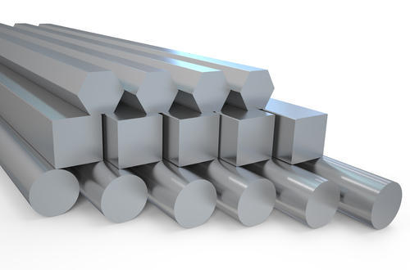
Figure 1 Al6061 Grade Aluminium
2.2. BORON CARBIDE (B4C)
Boron carbide is known as a robust material having high hardness, high cross section for absorption of neutrons (i.e. good shielding properties against neutrons), stability to ionizing radiation and most chemicals. Its Vickers hardness (38 GPa), Elastic Modulus (460 GPa) and fracture toughness (3.5 MPa·m^{1/2}) approach the corresponding values for diamond (115 GPa and 5.3 MPa·m^{1/2}).
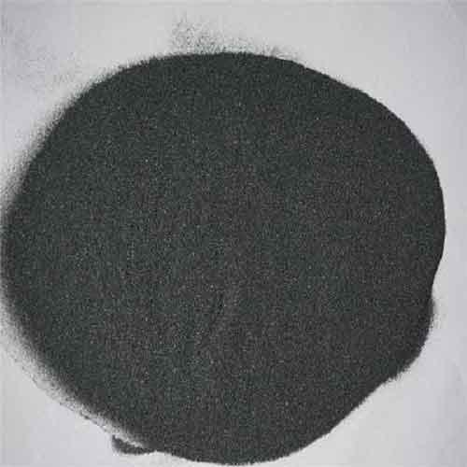
Figure 2 Boron Carbide Powder
2.3. Fly Ash
Fly ash or flue ash, also known as pulverised fuel ash in the United Kingdom, is a coal combustion product that is composed of the particulates that are driven out of coal-fired boilers together with the flue gases. Ash that falls to the bottom of the boiler's combustion chamber is called bottom ash.
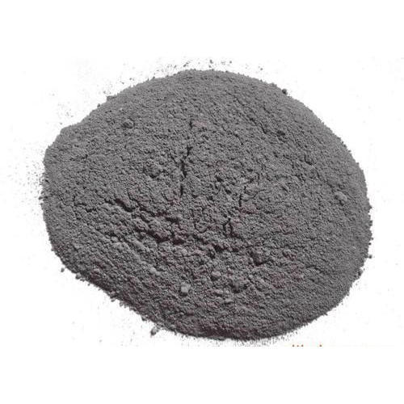
Figure 3 Fly ash Powder
3. Experimental Methods
3.1. STIR CASTING METHOD
In a stir casting process, the reinforcing phases are distributed into molten matrix by mechanical stirring. Stir casting of metal matrix composites was initiated in 1968, when S. Ray introduced alumina particles into aluminum melt by stirring molten aluminum alloys containing the ceramic powders. Mechanical stirring in the furnace is a key element of this process. The resultant molten alloy, with ceramic particles, can then be used for die casting, permanent mold casting, or sand casting. Stir casting is suitable for manufacturing composites with up to 30% volume fractions of reinforcement.
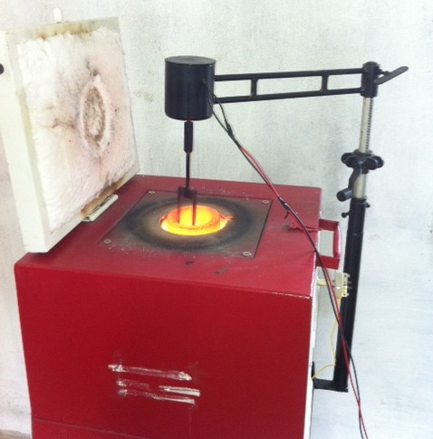
Figure 4 Stir Casting Furnace

3.2. TENSILE TEST
Mechanical testing plays an important role in evaluating fundamental properties of engineering materials as well as in developing new materials and in controlling the quality of materials for use in design and construction. If a material is to be used as part of an engineering structure that will be subjected to a load, it is important to know that the material is strong enough and rigid enough to withstand the loads that it will experience in service. As a result engineers have developed a number of experimental techniques for mechanical testing of engineering materials subjected to tension, compression, bending or torsion loading.

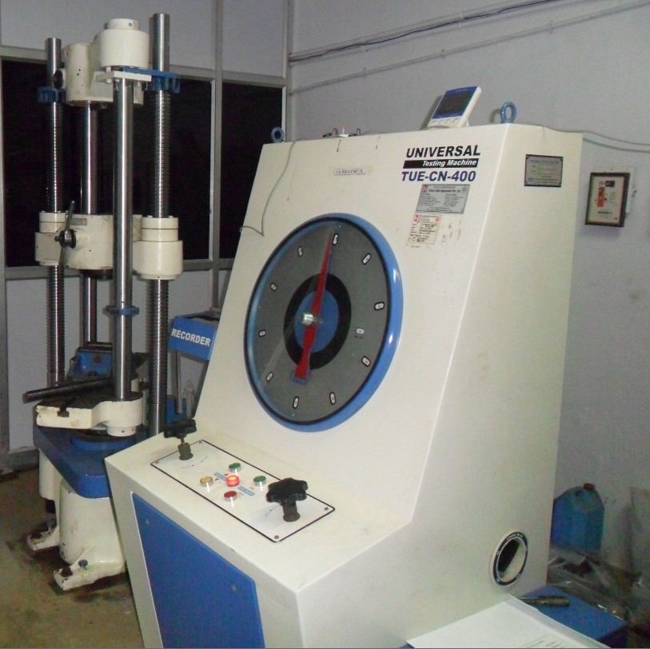
Figure 5 Universal Testing Machine (UTM)
3.3. Flexural Testing
The flexural testing also done in the similar way process of tensile testing with the 3 point bending setup with knife edge loads with the specimen size of 250mm length 25mm width and 10mm thickness based on ASTM Standards.
3.4. Impact Testing
Charphy impact testing is an ASTM standard method of determining the impact resistance of materials. A pivoting arm is raised to a specific height (constant potential energy) and then released. The arm swings down hitting the sample, breaking the specimen. The energy absorbed by the sample is calculated from the height the arm swings to after hitting the sample. A notched sample is generally used to determine impact energy and notch sensitivity.

3.5. Hardness Testing
The Vickers hardness test method consists of indenting the test material with a diamond indenter, in the form of a right pyramid with a square base and an angle of 136 degrees between opposite faces subjected to a load of 1 to 100 kgf. The full load is normally applied for 10 to 15 seconds.

3.6. Results and Discussion

Figure 6 Tensile Strength of the Aluminium Composites
The Tensile strength comparison of the aluminium composite materials AL 6061(90%) + B4C(5%) + FLYASH(5%), AL 6061(90%) + B4C(7.5%) + FLYASH(2.5%), and AL 6061(90%) + B4C(4%) + FLYASH(6%) better strength can be obtained from the AL 6061(90%) + B4C(7.5%) + FLYASH(2.5%) combinations only

Figure 7 Flexural Strength of the Aluminium Composites
The Flexural strength comparison of the aluminium composite materials AL 6061(90%) + B4C(5%) + FLYASH(5%), AL 6061(90%) + B4C(7.5%) + FLYASH(2.5%), and AL 6061(90%) + B4C(4%) + FLYASH(6%) better strength can be obtained from the AL 6061(90%) + B4C(7.5%) + FLYASH(2.5%) combinations only

Figure 8 Hardness value of Aluminium Composites
The Hardness value comparison of the aluminium composite materials AL 6061(90%) + B4C(5%) + FLYASH(5%), AL 6061(90%) + B4C(7.5%) + FLYASH(2.5%), and AL 6061(90%) + B4C(4%) + FLYASH(6%) better strength can be obtained from the AL 6061(90%) + B4C(7.5%) + FLYASH(2.5%) combinations only

Figure 9 Impact Strength of the Aluminium Composites
The Impact strength comparison of the aluminium composite materials AL 6061(90%) + B4C(5%) + FLYASH(5%), AL 6061(90%) + B4C(7.5%) + FLYASH(2.5%), and AL 6061(90%) + B4C(4%) + FLYASH(6%) better strength can be obtained from the AL 6061(90%) + B4C(7.5%) + FLYASH(2.5%) combinations only

4. Conclusion
Al6061-B4C-Flyash hybrid composites have been successfully produced by stir casting method up to 5wt% fly ash and 5wt% B4C.Ultimate tensile strength ofAl6061 based hybrid composites was higher when compared with that of the matrix alloy. Presence of content of hard silicon carbide reinforcement in the hybrid composites leads to enhancement in ultimate tensile strength of hybrid composites reinforced with graphite. Also the tests prove that the strength of the composite material fabricated is improvised and found to be better than that of the Al6061 and also the weight of the material is found to be less.

REFERENCES
- Surappa MK, Rohatgi PK. Production of aluminium –graphite particle composites. Met Technol 1978;5:358– 61.
- Son HT, Kim TS, Suryanarayana C, Chun BS. Homogeneous dispersion of graphite in a 6061aluminium alloy by ball milling. Mater SciEng A 2003;348:163–9.
- Lin CB, Chang RJ, Weng WP. A study on process and tribologicalbehavior of Al alloy/boron carbide composites. 1998;217:167–74. Jha AK, Prasad SV, Upadhyaya GS. Preparation and properties of 6061 aluminum alloy/graphite composites. 1989;32:309–12.
- Chawla N. and Shen Y.L., Mechanical Behavior of Particle Reinforced Metal Matrix Composites, Advanced Engineering Materials, 3, 357-370 (2001)

